LANDING PAGE:

LOGGED IN/SIGNUP

WHEN CLIENT LOGGED IN/SIGNUP



Pay the Premium:

Input/Output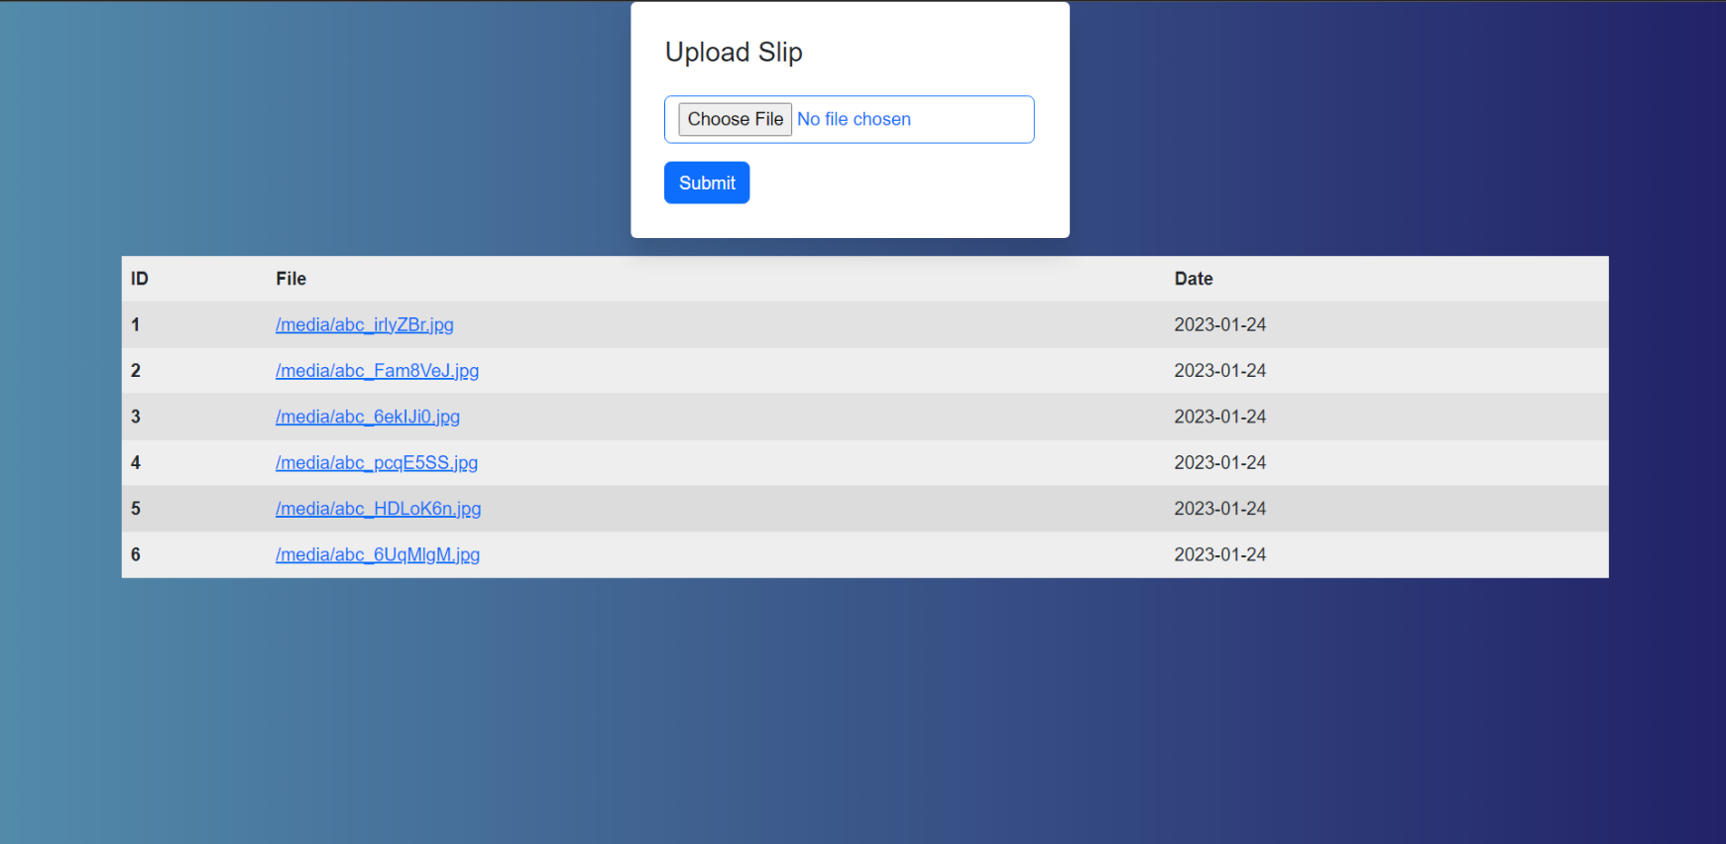:

Policy Form

Input

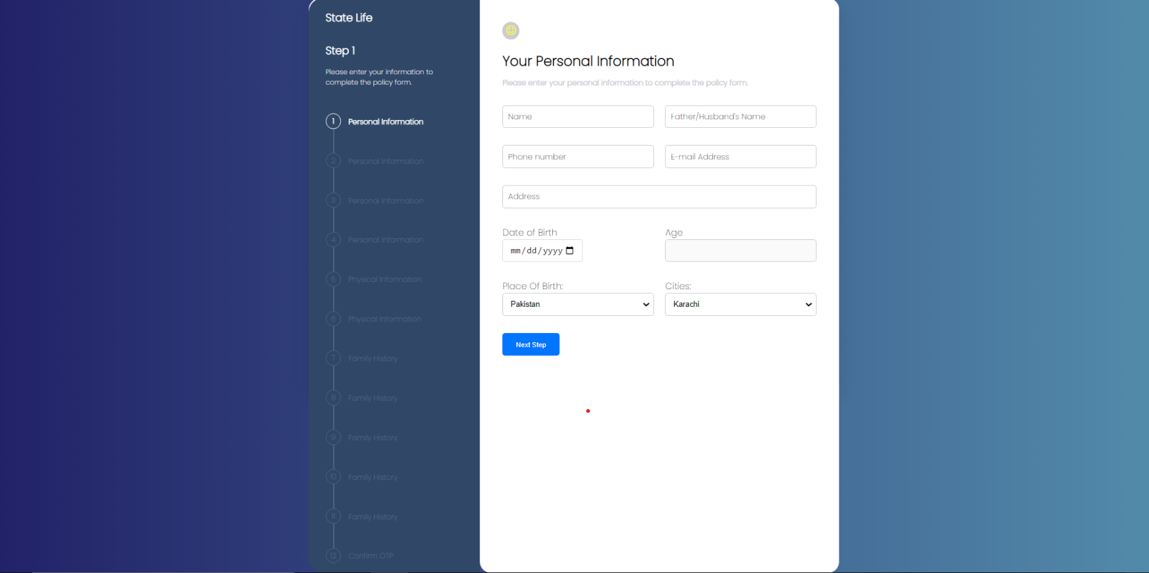

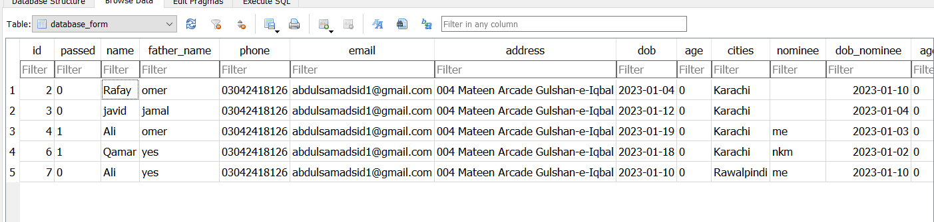

Input:

When Sales Manager Logged In

OutPut:

Sales Manger Page

Input/Output:

When Underwriter Logged In

Assessment Of Client Filled Form

Output:

On Approval of Client Slip send via Email in pdf Format to Client

Output:

